ANEXO II de la Circular N° 016-2004-SUNAT/A

DESIGNACIÓN SEGÚN LA COMISION ELECTRÓNICA INTERNACIONAL

LR

LR: ALCALINA
R: SALINA
SR: DE OXIDO DE PLATA
CR: DE LITIO
PR: ZINC –AIRE
MR: OXIDO DE MERCURIO

PILAS CILINDRICAS Y RECTANGULARES

PILAS ALCALINAS Y SALINAS

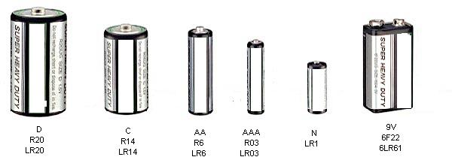

size | D | C | AA | AAA | N | 9V
IEC | LR20 | LR14 | LR6 | LR03 | LR1 | 6LR61 | Alcalina
JIS | AM-1 | AM-2 | AM-3 | AM-4 | --- | 6AM | Alcalina
ANSI | 13A | 14A | 15A | 24A | 910A | 1604A | Alcalina
IEC | R20 | R14 | R6 | R03 | R1 | 6F22 | Salina
JIS | UM-1N | UM-2N | UM-3N | UM-4N | --- | 006PN | Salina
ANSI | 13A | 14A | 15A | 24A | 910A | 1604A | Salina

PILAS DE LITIO

IEC | CR2 | CR17345 | 2CR5 | CR-P2
Nominal Voltage(V) | 3 | 3 | 6 | 6
Dimensions  (mm)(Max.) | 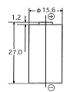 | 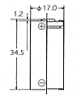 | 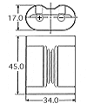 | 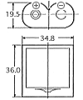
Grafico | 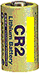 | 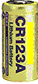 | 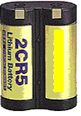 | 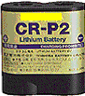

PILAS BOTON

PILAS ALCALINAS
J I S | LR1120 | LR54 | LR41 | LR43 | LR44 | 4LR44
Nominal Voltage (v) | 1.5 | 1.5 | 1.5 | 1.5 | 1.5 | 6.0
Dimensions  (mm) (max.) | 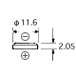 | 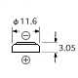 | 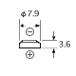 | 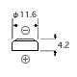 | 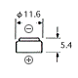 | 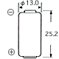

PILAS OXIDO DE PLATA

J I S | SR1120 | SR54 | SR43 | SR44 | 4SR44
Nominal Voltage(v) | 1.55 | 1.55 | 1.55 | 1.55 | 6.2
Dimensions
(mm)(Max.)

PILAS ZINC-AIRE

J I S | PR70 | PR41 | PR48 | PR44
Nominal Voltage (V) | 1.4 | 1.4 | 1.4 | 1.4
Dimensions  (mm) (Max.) | 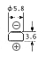 | 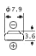 | 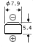 | 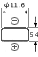

PILAS DE LITIO

J I S | CR1216 | CR1616 | CR2016 | CR2025 | CR2032 | CR2430 | CR2450
Nominal Voltage (V) | 3 | 3 | 3 | 3 | 3 | 3 | 3
Dimensions  (mm)(Max.) | 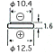 | 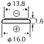 | 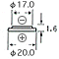 | 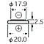 | 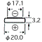 | 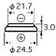 | 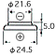
Grafico | 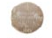 | 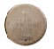 | 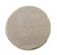 | 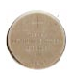 | 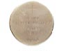 | 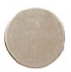 | 